Trustiu Web App

By

_________

Level-6

Final Project

Table of Contents

Project Proposal 3

Goals and Objectives 3

Project Scope 3

Project Specifications 3

Target Audience 3

Project Deliverables 4

Resource Requirements 4

Project Tasks and Milestones 4

Project Assumptions 5

Project Report 5

Detail Design 6

Home Page 6

Register Page 6

Login Page 7

All Sub Category Admin View 7

My Products Page View 8

All Products Page View 8

Sub Type Wise Product View 9

Product Details with Request View 9

Project Testing 10

User Manual 10

Summary 10

System Configuration 10

User Access Levels 10

# 

# Project Proposal

## Goals and Objectives

The main goal or aim of the project is to implement an online web application named “Trustiu Web App”. Sometime we purchase some product and after purchasing them, we regret. So Trustiu Web App is a web portal where Buyer upload details of his/her product and seller can request to buy them. This is the main purpose of the web application. In this application there are two types of users- admin and registered visitor. Admin has different functionalities as compare to registered user. Admin can add, edit, delete and check details of type and sub type of product. Registered user can add product as well as maintain them according to them and capable to request for purchasing other user product.

## Project Scope

The scope of this project is to implement an app named “Trustiu Web App”, with the help of this web application, user can sell their product as well as purchase other product. The duration of the project is 20 working days which is equals to 4 weeks.

## Project Specifications

* Admin login/logout
* Add, edit, delete and check details of Product Category as well as their sub category.
* Admin can register new admins.
* Registered User can login/logout.
* New Visitor can register.
* Registered User capable to add new product to web site for sell.
* Registered User capable to send request for purchasing the product to their seller.

## Target Audience

The target audience for this project is the people who want to sell as well as buy the products online. The age can go from 18 plus to 100 plus.

## Project Deliverables

The deliverables of the project are:

|  |  |
| --- | --- |
| Deliverable | Description |
| Final Report | This will be the final report of the project. |
| Coding | The executable code of the project will go under this. |
| Documentation | This portrays the documentation of the project. |
| Testing | All the test details will be covered in this part. |

## Resource Requirements

* Windows Operating System.
* Microsoft word for documentation.
* Asp.net MVC Framework
* 64-bit Processor and 4 GB or more RAM
* Identity framework- ASP

## Project Tasks and Milestones

|  |  |  |  |  |
| --- | --- | --- | --- | --- |
| **Tasks** | **Week-1** | **Week-2** | **Week-3** | **Week-4** |
| Brainstorming and analysis |  |  |  |  |
| Planning and initial meeting Project Proposal document. |  |  |  |  |
| Database Design and UI Design |  |  |  |  |
| Identity framework implementation |  |  |  |  |
| Coding for admin and reporter |  |  |  |  |
| Testing |  |  |  |  |
| Final Documentation and closing |  |  |  |  |

## Project Assumptions

Following are the assumption made while implementing the project:

* One admin and two registered users will be registered by default.
* Application will be free and open source.

# Project Report

#### Functional and Non-Functional

|  |  |
| --- | --- |
| Users | Functional |
| Admin | * Login/logout * Register new admins * Admin can add, edit, delete, check details for product category and their sub Categories. |
| Buyer / Seller | * Can view details of all products available at database * Registered user capable to add product to sell * Registered user capable to purchase the product by sending request * New customers can register for free. * Login using valid credentials |
|  | Non- Functional |
|  | * High speed * Fast Loading time * High performance and security * All browsers compatibility. |

## Detail Design

### Home Page

The main landing page of the application. On navigation bar options are- Home, All Category, Sell Product, Register and Login. This home page also displays the latest product to sell list.

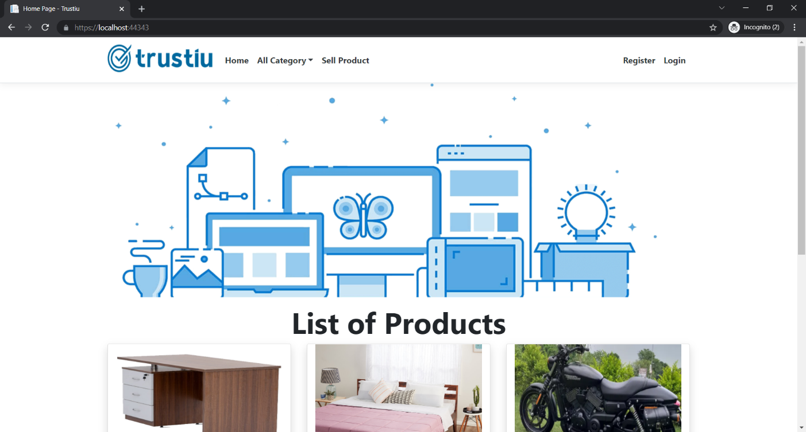

### Register Page

With the help of this page, new visitor can register online

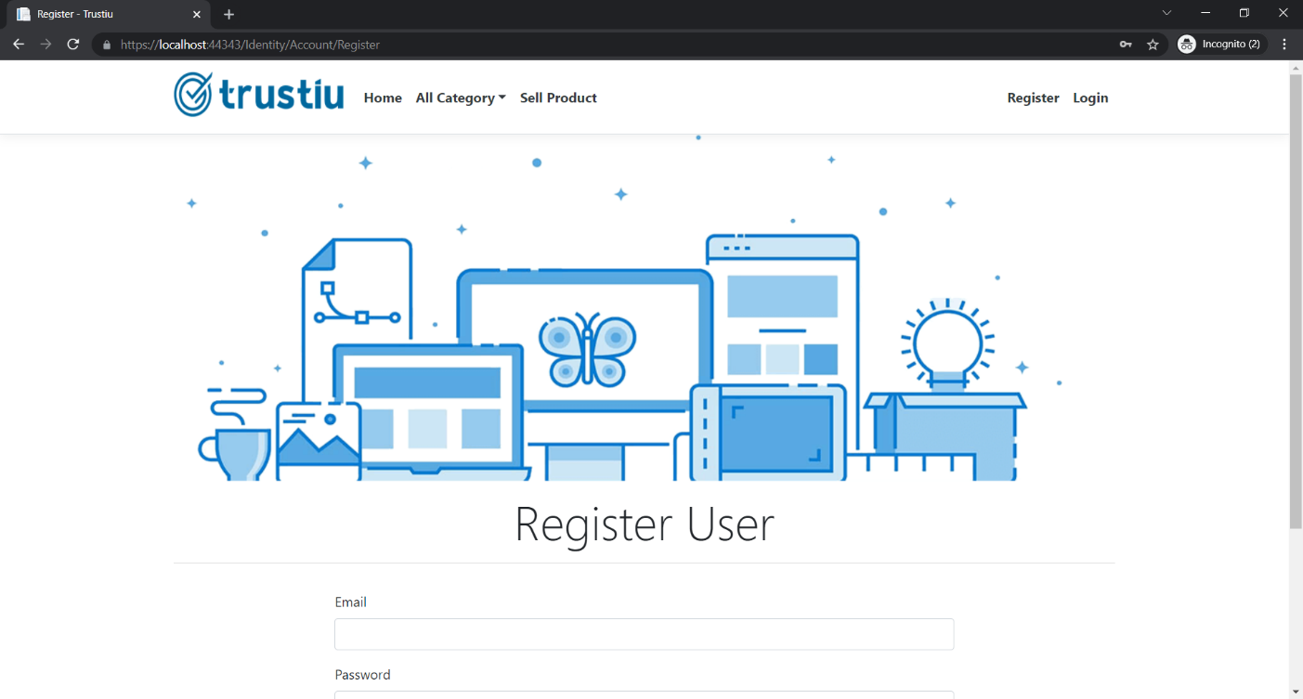

### Login Page

With the help of this page, visitor can login to page and access unrestricted page.

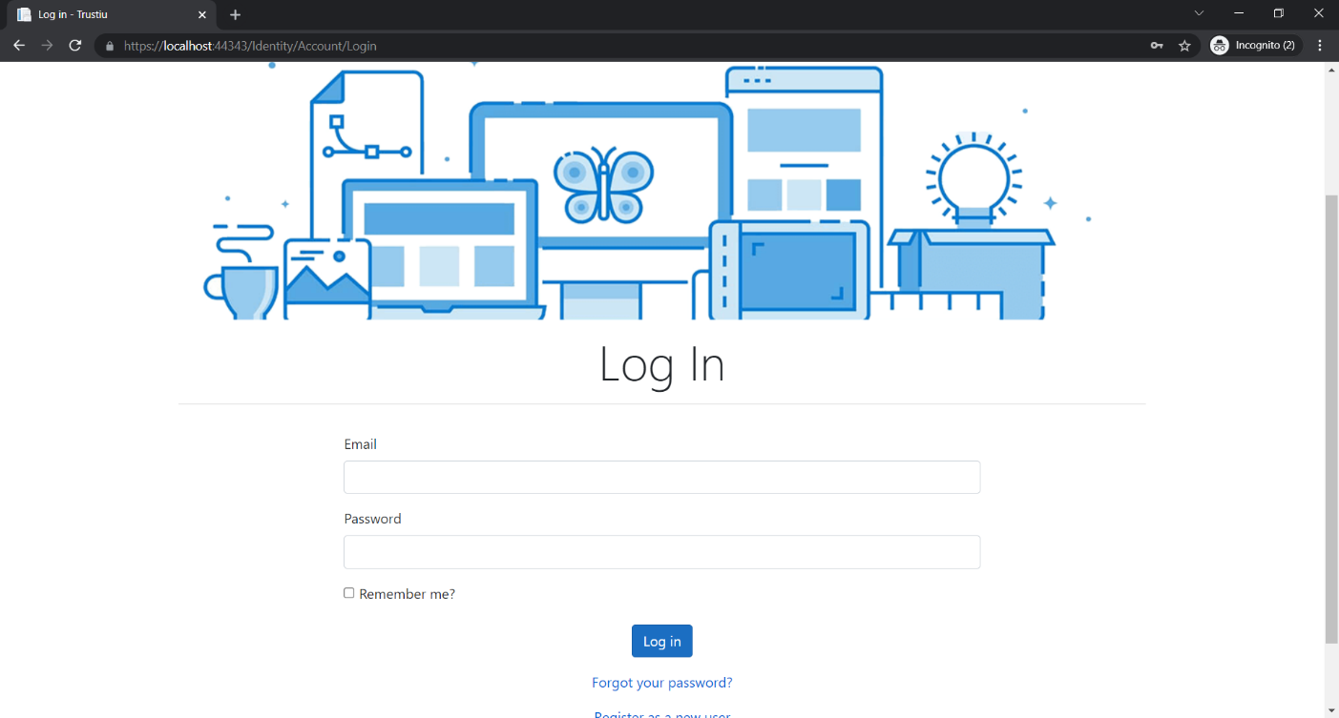

All Sub Category Admin View

This page provides a way to Admin View of All Sub Category Operations

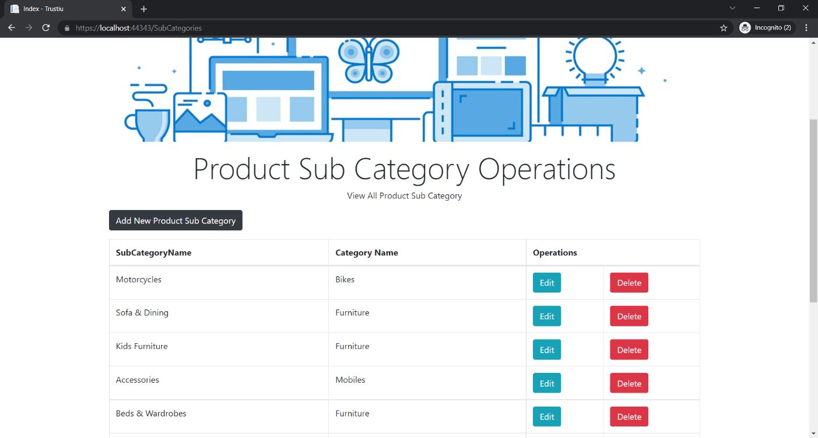

### 

### My Products Page View

With the help of this page registered user can view all product which are submit by himself/herself to sell.

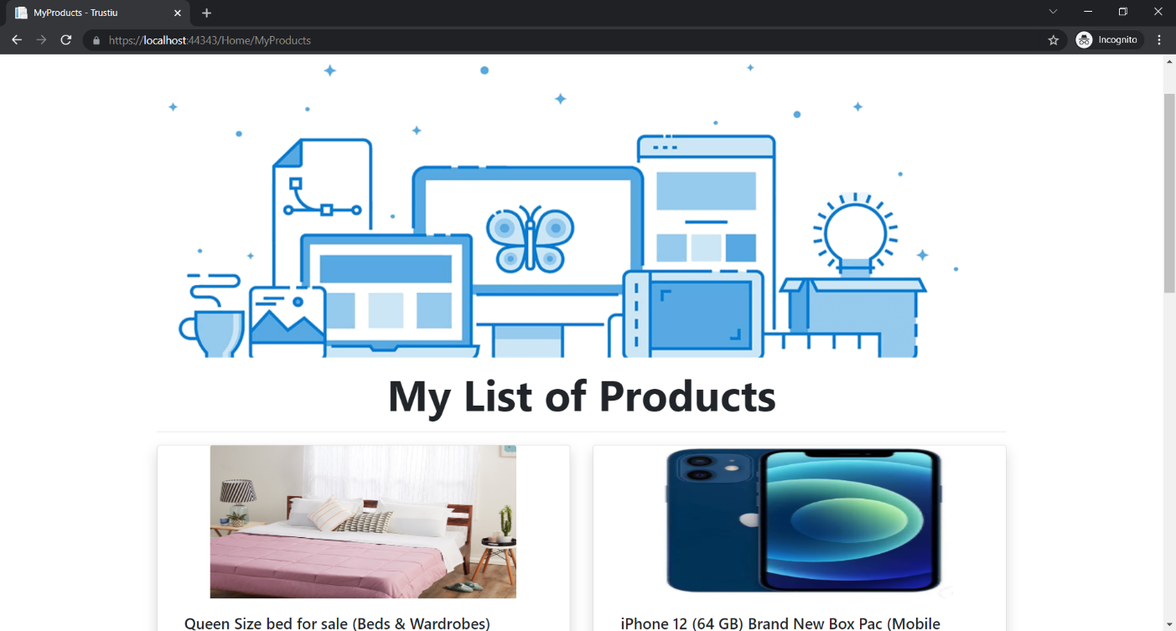

All Products Page View

With the help of this page Visitor/Registered user can view all product information with Details link.

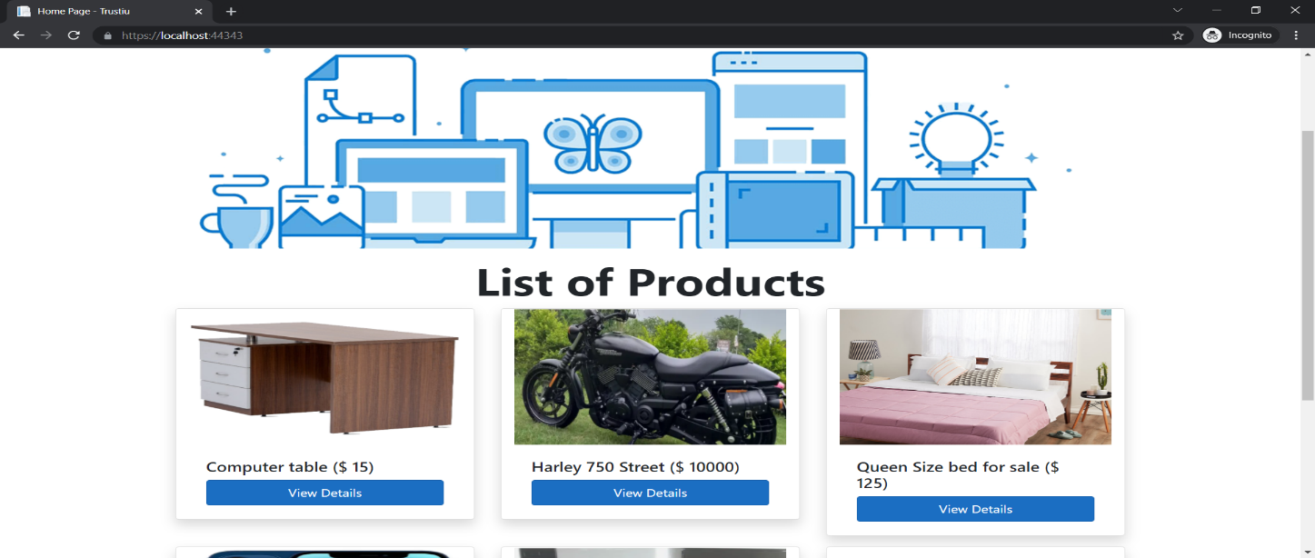

Sub Category Wise Product View

With the help of this page visitor can view all product of a sub category.

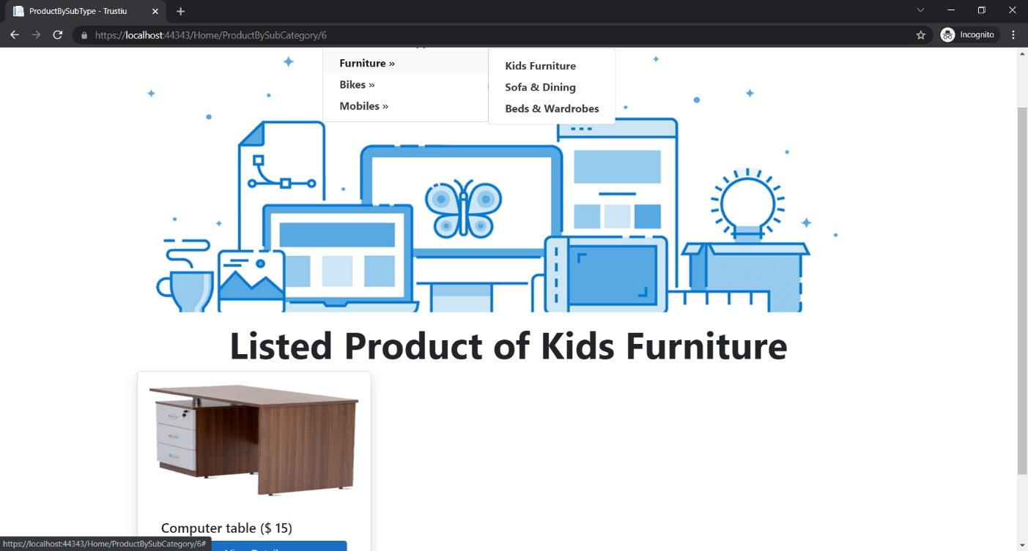

Product Details with Request View

This page shows the Product Details with all incoming Requests.

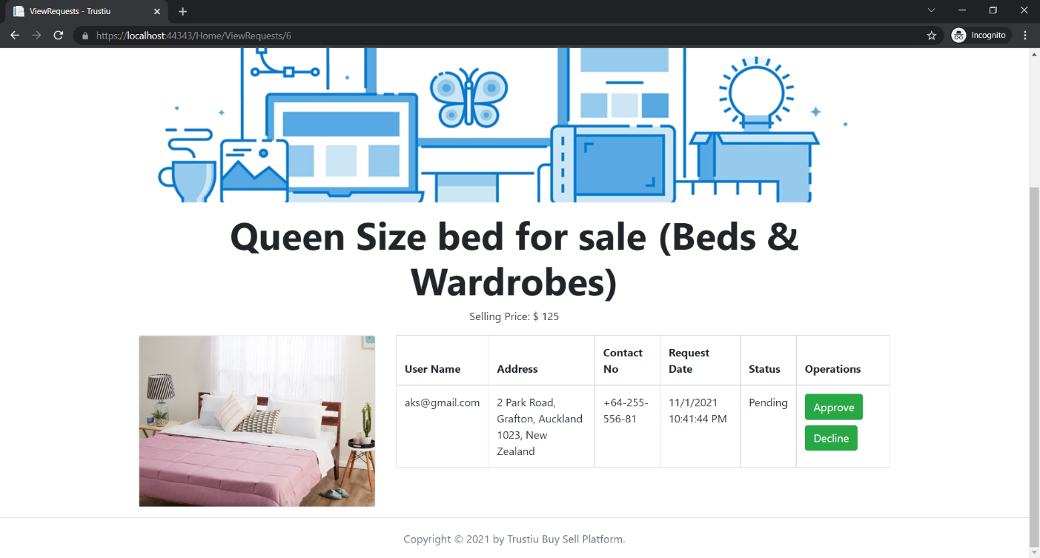

## Project Testing

The testing file for usability testing is attached as [usability test.xlsx](usability%20test.xlsx)

# User Manual

The main purpose of the application Trustiu Web App is to provide a portal where seller can submit their product details and buyer generate request to purchase them. In this application there are two types of users- admin and registered user or visitor. Admin has different functionalities as compare to registered user. Admin can add, edit, delete and check details of product type and their sub type information available at Trustiu Web App. Registered User is capable to add product for sell as well as request them to purchase.

## Summary

### System Configuration

This app will be useful to for distributing mobile information in presentable format.

### User Access Levels

Only registered users can access the features of this application.

* **Admin:** Admin has full access of the app can register new admins.
* **Registered Visitor:** New visitor can register and existing can login using their own credentials. They have limited access.